Dear Colleague,

We are writing to ask for your help in addressing the critical public health issue of under-vaccination of Maryland’s adolescents against the Human Papillomavirus (HPV). According to the Centers for Disease Control and Prevention (CDC), about 14 million people, including teens, become infected with HPV each year, posing a significant public health risk. HPV is a common virus that can cause several types of cancers affecting men and women including cervical, penile, anal, and throat cancer.

The HPV vaccine is recommended for preteen boys and girls at age 11 or 12 because it produces a more robust immune response during the preteen years, and to provide protection before exposure to the virus. The vaccine has been shown to be safe and very effective in preventing HPV. However, current Maryland data shows that vaccination rates for Tdap and meningococcal are considerably higher than those for HPV (>40% higher than HPV rates). This gap in coverage indicates missed opportunities to vaccinate boys and girls with HPV vaccine at the same time as other routinely recommended adolescent vaccines.

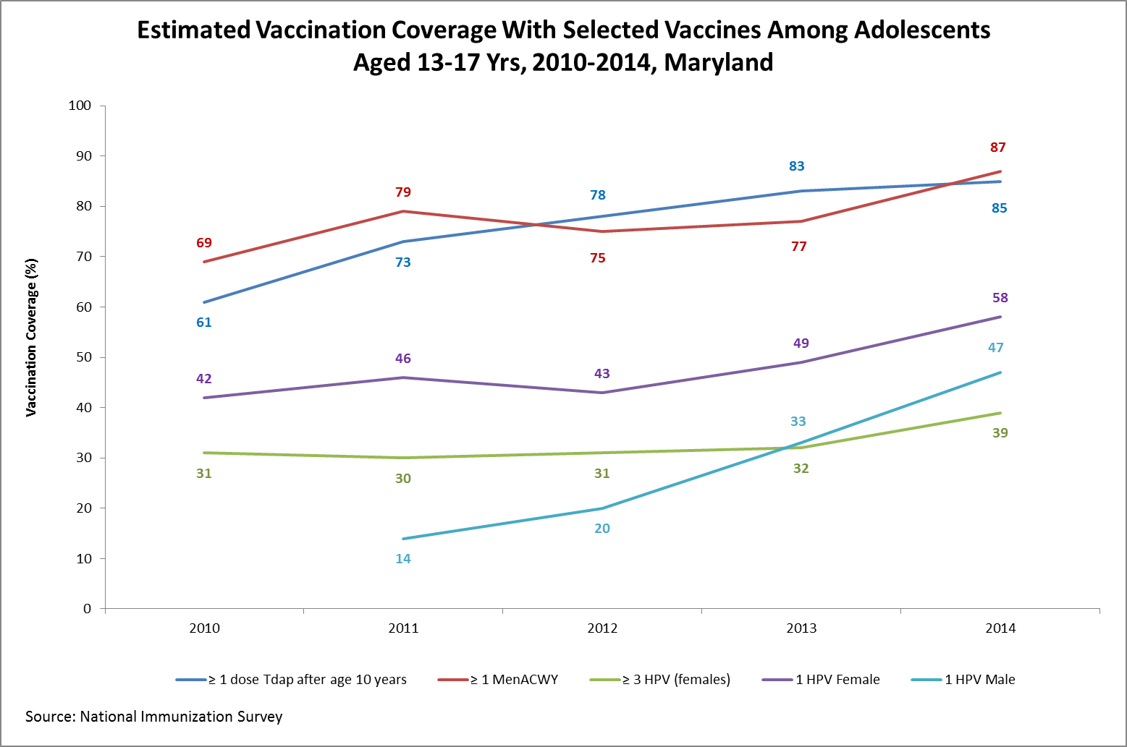

During the upcoming 2016 back-to-school season, it’s imperative to maximize the opportunities for age eligible children to initiate or complete the HPV vaccination series while they are visiting providers to obtain school-entry required vaccinations (Tdap and meningococcal) or for other services. As a physician, you can join this statewide effort and help to prevent cancer by increasing the uptake of the HPV vaccine among your patients, and encouraging completion of the full vaccine series. Physician recommendation has been shown to be one of the greatest influencing factors in parents’ decisions to have their children vaccinated against HPV.

To assist providers, the American Academy of Pediatrics has developed a continuing medical education (CME) course focused on strategies to strongly recommend the HPV vaccine and offers information on addressing parents’ concerns. Registration (at no cost) for the online CME course (expiring 10/8/2017) can be found at: https://goo.gl/rdPwDF

Additionally, the Maryland Department of Health & Mental Hygiene has developed a toolkit comprised of materials available at no cost to providers including: a fact sheet that may be used in conversations with parents, video/radio PSAs that may be used in office waiting rooms, and hold messages that can be used on office practice phone lines. The toolkit and other resources can be found by visiting http://phpa.dhmh.maryland.gov/cancer/Pages/HPV.aspx.

Thank you for all that you do to improve the health of Marylanders, and for your consideration of joining this important effort to prevent cancer by increasing the uptake of the HPV vaccination.

